Exercise With VR

CS 490-04 Undergraduate Seminar

Professor Marc Valesco

California State University Fullerton

Nebil S Gokdemir

**Table of contents**

I. Introduction

* Overview of VR Technology and its potential health benefits
* The goal of the Capstone Project

II. Abstract

* Description of the VR game and its features
* Benefits of the game for users

III. Technical Requirements

* Hardware requirements for VR gameplay
* Software requirements for game development

IV. Project Plan

* Tasks for 490 and 491

V. Requirements Engineering

* Game Requirements
* Metrics for success

VI. Architecture and Design

* Implementation Methods
* Prototyping
* UX Design

VII. Deployment and Distribution

* Building and packaging the game for different platforms (e.g. Oculus, SteamVR)
* Uploading the game to distribution platforms (e.g. Oculus Store) Marketing and promotion of the game

VIII. Conclusion

* Summary of the project and its potential impact on users Future work and improvements

**Introduction**

Virtual reality (VR) technology has gained popularity in recent years for its ability to create an immersive and interactive environment that mimics real-life situations. This technology has been widely used in the entertainment and gaming industries. Additionally, VR has the potential to provide users with health benefits by incorporating physical activity into the gameplay. In this Capstone project, the goal is to develop a VR game that combines entertainment with physical activity to create an engaging and motivating workout experience. The game will allow users to use VR controllers resembling boxing gloves to punch and destroy objects that come towards them. This incorporation of physical movements into gameplay provides an opportunity for users to improve their fitness and muscle strength while having fun. The game will be developed using Unreal Engine 5, and 3D assets will be created using Blender software. This project aims to provide significant health benefits to users and make exercise more convenient and enjoyable.

**Abstract**

This Capstone project aims to develop a VR game that provides an immersive and interactive environment for users. The user will use VR controllers resembling boxing gloves to punch and destroy objects that come towards them. The physical movements required in gameplay will help improve the user's fitness and muscle strength. The game will be developed using Unreal Engine 5, and 3D assets will be created using Blender software. The goal of this project is to create an engaging and motivating workout experience for users. The convenience of VR technology allows users to exercise anywhere and fit exercise into their busy schedules. This project has the potential to provide significant health benefits to users while making exercise more enjoyable. The project will require knowledge of game engines such as Unreal Engine as well as 3D modeling software such as Blender. Music for the game will be sourced either in unreal engine which is free or purchased online.

**Technical Requirements**

There are some hardware and software Requirements for this project. Game engines are responsible for running complex game logic, rendering graphics, and managing physics simulations. All of these tasks require a significant amount of computational resources, including CPU and RAM, so to able develop this Project it require good computer. Another requirement will VR headset (e.g. Oculus) to test game when it done. As Software, I need install unreal engine 5, and 3D modeling and animation software such as Blender.

**Project Plan Include task for 490 class and 491class**

My plan for 490 class is define project goals and requirements, and create project timeline. Since I will create and develop this project, there is zero Budget. Also, I will choose one VR headset to develop my project for it because each platform has its own requirements for uploading games. However, if I have time, I will do for another VR as well. Finally, I will learn Unreal Engine 5 and Blender Software. Since I am not taking summer class, I will also learn Unreal Engine 5 and Blender Software in summer as well, so I won’t have any difficulty when develop this game in next semester. In 491 class, I will create 3D models of game objects using Blender software. For sound, I will use Unreal Engine’s music and sound effect. After I have all assets, I will implement game. Finally, I will do final presentation for capstone project

**Requirements Engineering**

1. The game must include a user sign-up feature, with a unique email required to create an account. User data must be stored in a database, with each user assigned a primary key.
2. The game must have objects that move towards the user. The user must destroy the objects to earn points. Upon successful destruction, an animation and music will play.
3. The game must have multiple levels with different speeds and trajectories to provide a challenging experience. The user must reach a certain point threshold to progress to the next level.
4. The game should have a leaderboard to display the high scores of all users from database, and while playing can see his current score if his current score pass highest, it will replace with.
5. The game must be designed and packaged for Oculus. If time permits during class 491, the game will be packaged for different VR platforms as well.
6. The game should have a menu that allows the user to adjust game settings, such as volume

**Metrics**

1. Active users: Measured by the number of users who download and play the game regularly. This metric can be used to track the game's popularity and engagement.
2. Workout effectiveness: Measured by tracking the time user spent playing the game and the number of calories burned during gameplay. This metric can be used to measure the effectiveness of the game in providing a workout experience (in future if put game in cloud)
3. User satisfaction: Measured by collecting user feedback through social media or ratings on distribution platforms such as Oculus Store. This metric can be used to improve the game and identify areas for future development.
4. Revenue: Measured by tracking the amount of revenue generated from game sales or in-game (Adsense). This metric can be used to measure the game's profitability and the effectiveness of the marketing and distribution strategies.

**Deployment and Distribution**

Once the game is developed, it needs to be distributed and made available for users. This involves building and packaging the game for different platforms such as Oculus, SteamVR, and Viveport. Each platform has its own requirements and guidelines for uploading games, so it is important to ensure that the game meets these requirements. The game can be uploaded to distribution platforms such as Oculus Store, Steam, and Viveport as well. These platforms provide a way for users to download and purchase the game. I will focus on Oculus, and if have extra time in 491 class, I will do for another platform as well. Marketing and promotion are also important for the success of the game. Social media platforms such as Facebook, Twitter, and Instagram can be used to promote the game and reach potential users. Creating a website for the game is also a good way to provide information about the game and attract potential users.

**Architecture and Design**

1. User Interface and Navigation System: The game will have a user interface that is easy to navigate and understand, even for users who are new to VR. The user interface will allow the user to adjust game settings such as volume. A navigation system will be implemented to able the user to move around the game world and interact with objects.
2. Physics and Collision System: The physics and collision system will be responsible for simulating realistic physics in the game world. This system will handle the movements of objects in the game, including the objects that the user punches and destroys. The collision system will detect when objects collide with each other, and trigger the appropriate sound effects and animations.
3. Object Spawning and Movement System: This system will be responsible for spawning objects that the user can punch and destroy. The objects will move towards the user at different speeds and trajectories to create a challenging and engaging experience (depend which level user at). The system will use a random number generator to determine the position and speed of the objects.
4. User Input and Controller System: The user input and controller system will be responsible for detecting the user's actions and translating them into actions within the game. The system will detect when the user punches or makes other movements, and update the game accordingly. The system will use VR controllers that resemble boxing gloves to provide a realistic and intuitive input method.
5. Sound and Music System: The sound and music system will provide appropriate sound effects and music to enhance the user experience. The system will use Unreal Engine 5's built-in sound effects and music, as well as external music sourced online if needed.
6. Database System: The database system will be responsible for storing user data, including user login information and high scores. The system will use SQL databases to store the data and retrieve it as needed. The leaderboard system will also be connected to this database, displaying the high scores of all users.

**UX Design**

After users sign up, they will be able to play a game where they have to destroy objects that will come towards them with his pink laser saber (different level will be boxing gloves). They will earn points for destroying these objects and advance to a new level once they reach a certain point threshold. As they progress, the objects will become faster and more challenging. Additionally, the game design will be different for each level. An image below is just to show how the game will look, with the user's current points displayed in the top left corner and the maximum points for all users displayed in the top right corner. This data will be saved and retrieved from a database.

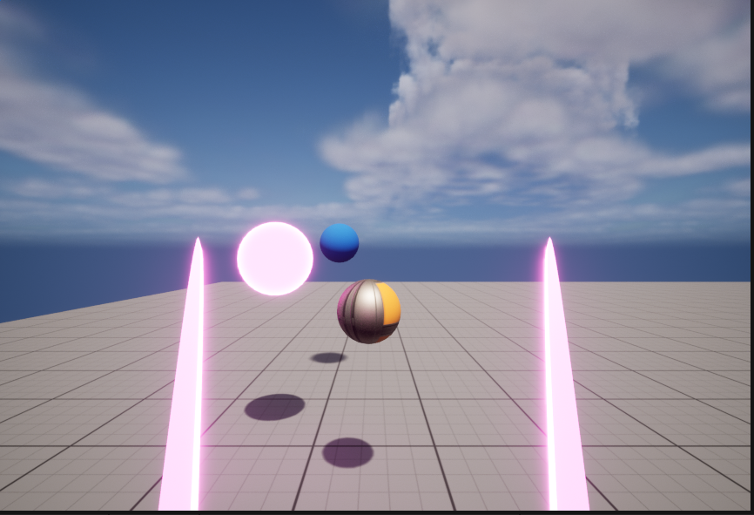

**Prototyping**

This is blueprint code alternate to c++ in Unreal Engine and this blueprint code move Camera to location of player.

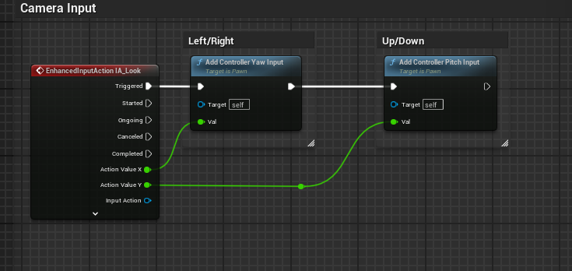

This blueprint code creates a pink laser saber. The Fresnel method determines brightness of the color and glow method determines the light. Set up Glow method 1000 to make it 1000 color times stronger.

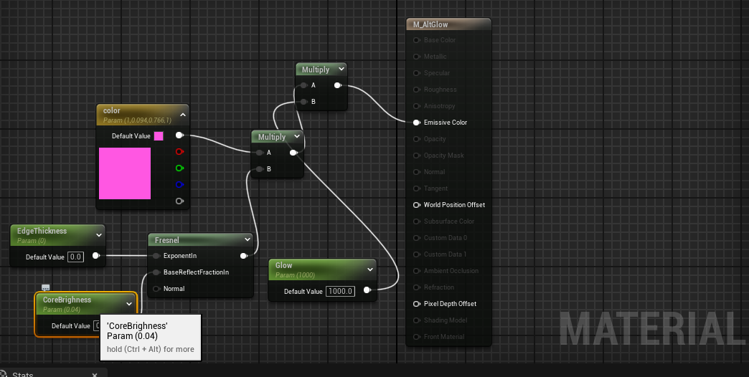

This blueprint change vector location of player when he moves left-right, and forward-backward.

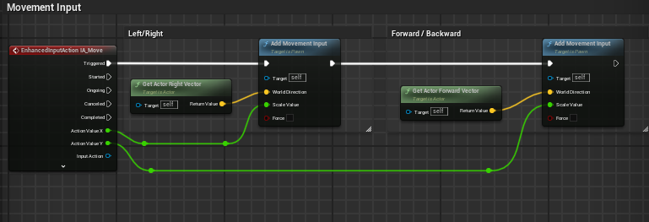

**Implementation Methods**

I have decided to use Agile Methodology for this project, with eight sprints planned, each lasting two weeks. Even though I have provided blueprint example, I plan to use C++ for this project and will be using Xcode as my editor, as it provides helpful error messages and is well-suited for implementing C++ code. As I am implementing the project, I will use GitHub for version control, with each sprint having its own branch. At the end of each sprint, I will merge the sprint branch with the main branch.

**Conclusion**

In conclusion, this Capstone project aims to develop a VR game that combines entertainment with physical activity to create an engaging and motivating workout experience. By using VR controllers resembling boxing gloves to punch and destroy objects that come towards the user, the physical movements required in gameplay will help improve the user's fitness and muscle strength. The game will be developed using Unreal Engine 5, and 3D assets will be created using Blender software. The convenience of VR technology allows users to exercise anywhere and fit exercise into their busy schedules. This project has the potential to provide significant health benefits to users while making exercise more enjoyable. The project will require knowledge of game engines such as Unreal Engine as well as 3D modeling software such as Blender. The game will be tested and optimized for a VR headset and will be uploaded to distribution platforms such as Oculus Store. By measuring metrics such as active users, workout effectiveness, user satisfaction, and revenue, the success of the game can be evaluated. This project has the potential to provide users with a new and exciting way to stay active and healthy.